3D Printing experience and learning

Document Preface
This document describes the experiences and learning after about 2 years of using the 3D printer. It is divided in 3 parts
- The hardware
- Printing itself with tips and tricks
- Software used and settings to pay attention too

3D Printer hardware

Original Machine
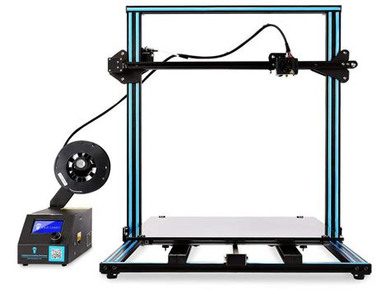
The original machine is a CR10s5 made by creality. Creality is a Chinese based company, who started their design based upon the Anet A4 printer. It is what is called a cartesian printer (XYZ) system. The printer is an open system (not covered on any side) using an aluminium 2020 frame, control box and multiple stepper motors to driver the printers.
This machine is very popular with tinkers, makers and hackers due to the high amount of modifications available for it. At the time of selection, this machine was intended as a learning machine with single specific print job in mind.
Being a tinkerer machine, it is not straight forward to operate initially. Each of these machines has small unique difference (steps of steppers etc) that require the operator to get to know the machine.
Although this is a very fun machine, it does raise the question if anyone can use it and if within a professional environment, this is the right tool

How it works
The printer uses GCODE language (also used in CNC machines) to operate it. GCode tells the printer e.g. which movements to make, what temperature to heat the hotend or the bed etc. The full gcode spec can be found here https://marlinfw.org/meta/gcode/

The main parts of the printers
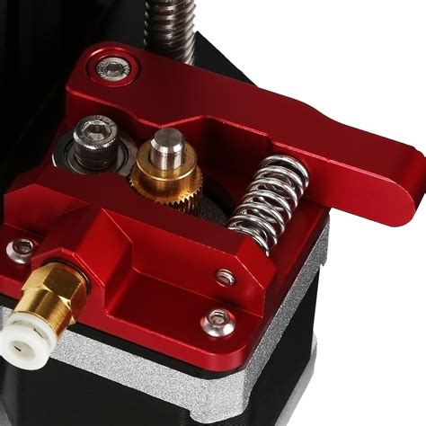
Extruder: this is the stepper motor that drives the filament to the hot end. It is a simple system where the filament is grabbed by 1 teethed pulley and a blank one, and the stepper pushes the filament in the bowden tube towards the hot end.

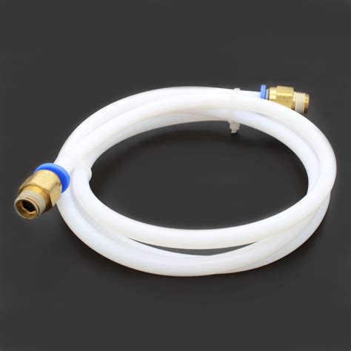
Bowden Tube: This is a PTFE tube which guides the filament.

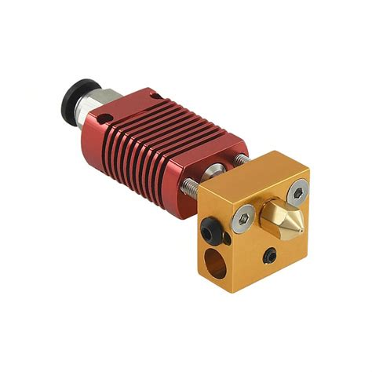
Hotend: this could be seen as the print head. It is the part that will heat and melt the filament.
It consists out of 3 main items
- The heater block: the bottom part (in copper on the picture, don’t mistake for the nozzle), has a heater cartridge and a temperature sensor. The mainboard puts current on the heater cartridge to warm it. The sensor keeps this process under control.
- The thermal break : (not visible on the picture) sits inside the radiator and connect the bowden tube to the nozzle
- The radiator :(The red part on the picture): this is actually intended to reduce heat creep of the heater block upwards in the printer
- The nozzle: this is the actually part where the filament is pushed through. This is wear part and replaceable
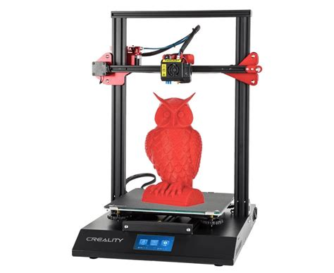
Gantry (or z-axis)
This is the horizontal bar on which the hotend moves . It is driven by 2 steppers motors to set it to the correct Z position or height. The hotend itself is moved on a drive plate by a belt system and 1 stepper motor. This way the X position is set

Heated Bed
The heated bed is the actual plate used upon which we will print. This is moved in the Y direction by a belt system and 1 stepper. Important on the CR10s5 is to know that you have inertia which impacts the print and speed, due to the weight of the bed. On top of the bed a glass plate is put, to have a better adhesion. Often a mirror is preferred as this is flatter than the glass, yet this upgrade has not been done, due to not finding the right size mirror at an acceptable cost and no actual need in my opinion.
Our bed is a heated version, more on printing on a heated bed further in the document.

Modification applied
In the past 2 years, several modifications have been installed and/or removed because of other modifications. The purpose of the modifications has always been to improved either print quality, stability and sound level.

Machine modifications

Squash ball feet
This modification allows you to use softer squash balls as feet for your printer. The reason is to reduce the amount of vibration of the bed during quick movements or turns. (These turns result into ringing or ghosting. See further)
This modification did not bring a lot of changes, but does help to reduce the amount vibration to the desk.
Advice: Nice to have but not crucial, low cost to perform (4 squashballs and some filament)
https://www.thingiverse.com/thing:3000009

High clearance fan mod
This mod is mainly an aesthetic modification. Having a high clearance fan, allows you to see the printed part better. It does help you when you want to switch your nozzle, but as the screw that hold the hotend also hold this fan mod, it introduces a bit of slack on the whole mechanics. This can result in what appears to be a shifting in the layer.
It is not try Z-shifting or the gears missing a step, but actually the following:
as the nozzle travels across the infill, it would bump a bit of plastics. Due to this slack, the hotend would tilt slightly to the left or right. From that point on ward the nozzle is not exactly on position X but on X + or – a small deviation. This appears as if there was a jump (skipping a teeth on the gear). I lost over 2 weeks trying to solve this.
Advice : In my opinion a must have as it really increase visibility on what you are doing, but keep in mind that everything is properly tightened before you print.
https://www.thingiverse.com/thing:3206459

Stabilizer on the Z-axis
As this is a large printer that can go really high, there is a low of stress on the upwards aluminium profiles. To reduce the amount of wobble , there is a modification to add a re-bar to between the bottom frame and the vertical frame.
Advice: highly recommended when doing higher prints.

Filament guide and filament holder top mounting
To reduce space, the filament holder is mounted to the top of the frame (previous mod required as the weight of the frame is increased). To do a proper guiding to the extruder and create a smooth path, print a filament guide
https://www.thingiverse.com/thing:2917932
Advice: recommended space saving mod

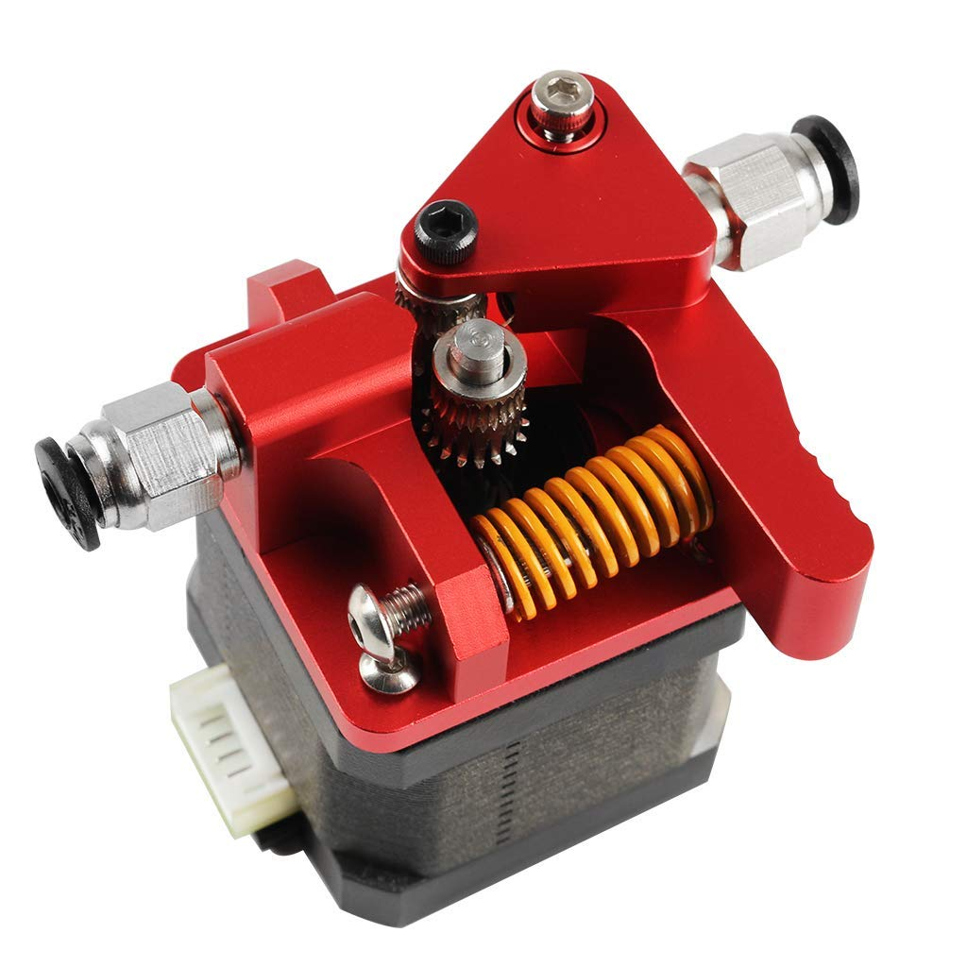
Dual gear aluminum extruder
The original extruder is a plastic version. Although this works , it easily breaks and make your filament skip. The extruder was first changed to a full aluminum with a single gear. Later it was exchanged for a dual gear extruder (in aluminum). A dual gear extruder has both pulley as gears and not 1 gear and 1 pulley. This provides you more stable extrusion.
Advice : Recommended influcences the accuracy of the print

Capricorn Bowden Tube
Capricorn is a well known manufacturer of PTFE tubes. They provide less friction on the throughput of the filament. Ordered via amazon.
Advice : Recommended influcences the accuracy of the print

BL Touch
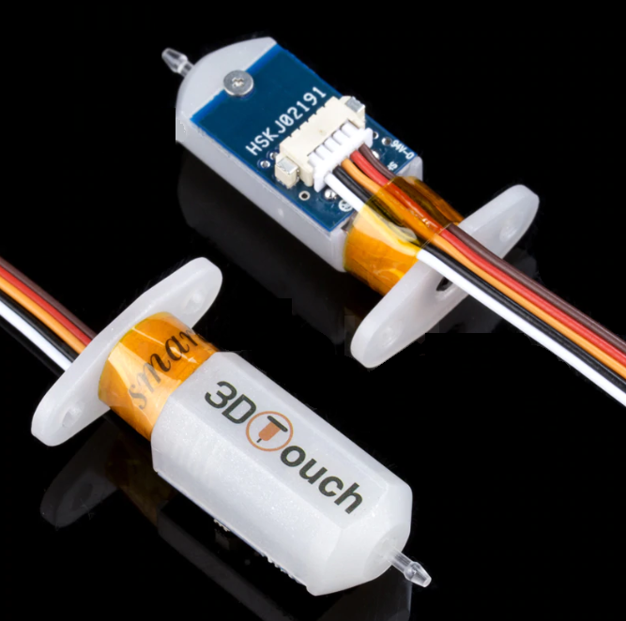
A BL Touch is a bed levelling (Hence BL) sensor. Levelling the bed is the most important part before you start printing. This means that the bed is parallel towards the gantry. Yet, the plates and glass plate can have deviations or deformations. A BL touch measures the deviations of the bed and translates that in a mesh. This mesh is then applied during printing, making sure that the printing is flat.
This does require a firmware update and proper installation/connections on the mainboard

Advice : Recommended influcences the accuracy of the print, would even put it as required

TL Smoothers (removed)
In a first attempt to reduce the sound of the printer during movement, TL smoothers were installed. These boards are meant to smooth out stepper motor torque and movements for cleaner motion simply by placing diodes in series with the motor.
Advice: Don’t install a waste of money.

Vibration dampener
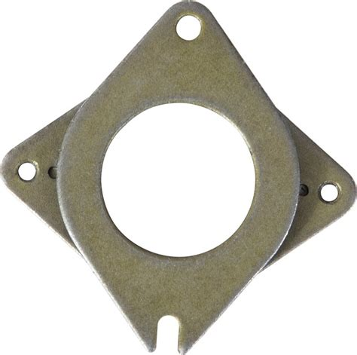
It is said that vibration dampener will reduce the noise of your printers and make for a better print. The results are not significant to actually install these and due to the low quality of these parts, it was noticed that they would wear very quickly (one actually tore in 2 and placed a heavy stress on the axle of the motor
Advice: Don’t install; a waste of money.

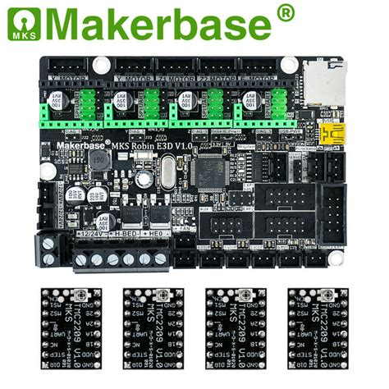
Mainboard replacement
The mainboard was replaced with a native 32bit makerbase Robin E3D mainboard with the latest TMC2209 drivers.
This board heavily improved noise. It is absolutely silent now due to the new driver boards. It also allows you to perform babystepping (really accurate location of the stepper motor) as well as increased the print accuracy (due to 32bit instead of 8 bit)

Advice: must have

All metal hotend

And all metal hotend is different from the normal hotend in such a way that the bowden tube is not so close to the heater block. The usage of such a hotend is mainly driven to be able to print other materials that require a higher temperature.
In my experience this was a real pain. Due to this being all metal, you cannot perform retraction (see further). When you retract the filament, the molten filament goes into the cold zone, causing it to solidify and generate a cloth. I removed it after 2 days, as this has no value to me only printing PLA/PLA+ and that the other materials (PETG/ABS/Nylon) give toxic fumes
Advice : not needed unless you have the printer in a ventilated location and print toxic materials.

Optional modifications

Octoprint on raspberry pi
Octoprint (octoprint.org) is a software to drive your printer. It gives you better control, additional features (like firmware upgrading), remote access (when connected to the internet) and much more.
In this specific setup, the filament out sensor is connected to the raspberry pi. When this is triggerd, the printer will go in a paused state, park the nozzle in a safe spot and wait for the operator to load a new filament.
Add-on: In my case, the octopi is connected to my home automation system. If the printer goes in pause , I get an SMS (using MQTT and clicatell). It also shuts down the printer (wifi enabled power socket) and the raspberry pi (so the system itself).

Webcam
The printer has a been fitted with a webcam which is connected to octoprint, allowing the user to remotely check the machine.

Modified filament sensor holder
To increase the path of the filament, a modified filament holder was created, which is mounted un the extruder.
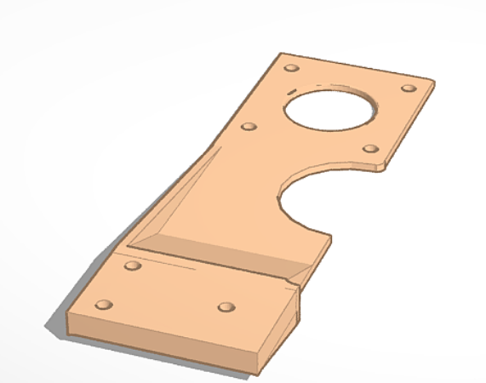
Then the mount is placed on there. Later I replaced the cover with an open cover system. This allowed for easier installation of the filament

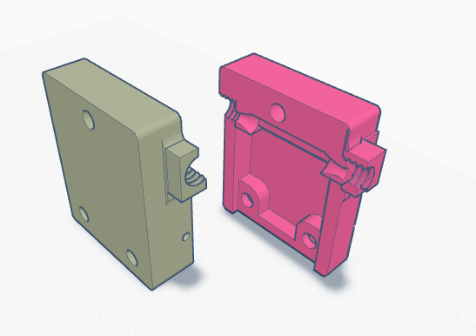
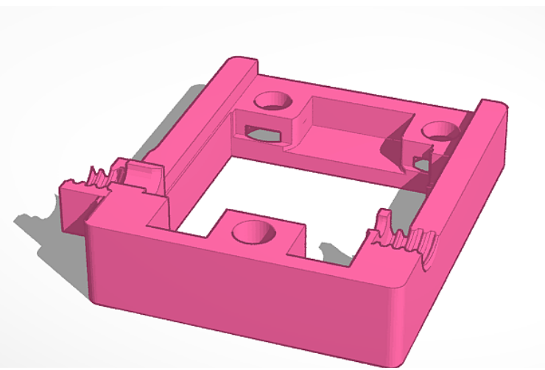

Experience and failures

Mechanical issues
- The machine requires you to tighten all screws every so often. Due to vibrations and movements, these tend to comes loose, reducing print quality.
- The X and Y movement are belt driven. These belt will get longer due to movement and require you to tension them every so often. An untensioned belt, will result in skipping teeths of the gears and causing a bad print. There is not exact value on how much to tension it, some state that the tension of the bed needs to sound like a bass C note, but nothing measurable. For the X-axis it is even more trial and error.
- Broken stepper motor for the Y-access. The axle suffered metal fatigue and had to be replaced.

Printing errors
Several issue experienced due to bad adhesion, wrong software slicer settings. The printer also lost power once. This was not reproducable.

Overall printer conclusion
As a tinkerer I love this printer. But as a professional user I think it is bad. In a world where you want to walk up to it and start a print, this is not the ideal printer. It requires several minutes up to an hour of checking before you can start with each print.
Due to the fact that this printer is not enclosed you are limited to materials for printing and exclude ABS. Mockups in PLA are fine, but prototypes would have to be in an ABS for strength.
From a safety point of view, all gears and moving parts are exposed. I took the test of letting the bed bump my hand at full speed and it had a bruise for over 3 days.
It does require a lot of changes (as seen in the modifications) to make this a proper, fully functional printer.
For a professional environment a closed version of a 3D printer is advised (like ultimaker or dremel). For a home printer this is fine.

3D printing software

Slicer
As a slicer (translates 3D files in GCode) Cura was used. The latest available version was always used. This is a free software under an open source license made by ultimaker
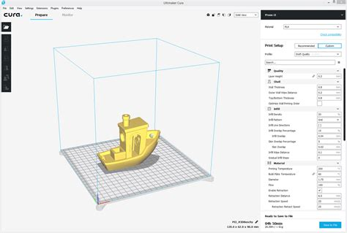

Design software
For initial design tinkercad was used. This is a basic 3D design software, making use of addition of subtraction of one object with another. It is basic, but does the job for small items.
Next level up, was basic usage of Freecad (freecad.org). This is an open source CAD program similar to AutoCAD , written in Python.

Printing tips and tricks

Bed leveling (without BL Touch)
It is crucial to make sure that the bed is parallel with gantry. This is done by lowering the gantry so the nozzle barely touches the bed and sliding a piece of paper under it. You should just be able to move the paper when the bed is properly levelling. You need to do this on 4 points at least, preferably 9 points.
You need to level the bed before each print. When the power is off, the motor are freely movable. Due to gravity the gantry will slowly drop. This is not with the same amount on both side, hence the gantry is often not level.
TIP: use a level to level the bed first, next take 2 blocks of the same height and place them on the bed (e.g. 5cm). Manually lower the gantry by rotating the bars until it rests on the 2 blocks. This way the gantry and bed are largely parallel to each other. Now start the actual bed leveling.

Bed leveling (with BL Touch)
When a BL touch is installed, you can use the trick of the blocks and skip the paper levelling.

Distance between nozzle and bed
When you use a BL touch and the bed is autoleveled, you can still end up with the nozzle being too far from the bed. This is due to the vertical distance of the nozzle and the bottom side of the feeling pin of the BL touch. You can adjust this inside the printer firmware (Tune, advanced, BL Touch Offset). Lower or raise as needed while printer a skirt of the first layer of your print.

Steps (or E-steps)
The steps in your firmware are the amount of steps you need to proceed X mm. This is done by printing a calibration cube. The cube is 20x20x20mm. In your firmware or through the terminal you can check your current setting for X,Y,Z and extruder. E.g. X is 80. After printing the 20x20x20 cube you use a caliper to measure it. Let’s say that this result to an actual print of 18x20x20. In this case you know that your step setting of 80, does not give you the 20mm you requested, but only 18. So, you will need to increase the step for X. You can easily calculate this by doing
New step = old step / actual size * requested size = 80/18*20=88.88. You can now update this in the firmware using M92 X88.88. Store it by issuing M500 and check with M503.
Do this for each of the 3 axis.
Another type of steps is the extruder steps. This is how many steps the extruder would need to push X mm of material. There are 2 ways of doing this: free air calibration or normal calibration. In the first case you simply disconnect the bowden tube right after the extruder so it is not pushed through the hotend. In the second type you keep all as is.
The preference is for free air calibration as there is no influence coming from resistance of the bowden tube, the hot end or maybe a partial cloth.
The process is similar to the above. You check the current value of your E-steps and request the printer to “extrude” 10cm. Next you measure how much was extruded. If less, you need to increase the value, if more, you need to decrease it. The formula is the same as above.
New step = old step / actual length * requested length.
Each roll of filament can be different. When changing color or brand it is recommended to calibrated the e(xtruder)-steps. Yet, when using open calibration, you can reduce this as there is no resistance of any kind on the motor. What you do need to do it check and modify the flow rate of the filament during print.
As, maybe due to temperature or resistance in the bowden tube, there might be a change in the amount of filament pushed through the hotend, this value changes the e-steps with a multiplier.
So imagine that you have and free air e-steps of 100. Now, when you print you notice there is too much filament flowing (e.g. stringing / blobs on the print).Use the flow rate to reduce it to 95%. This would be the equivalent of placing the e-steps on 95. Why is this better? This deviation is not due to the motor not trying to push the right amount, but e.g. due to the material not being 1.75mm everywhere. Or there might be more friction of the PLA in your bowden due to the chemical used to color it.
Since I moved to open air calibration, I hardly touch my e-steps.

Ready for printing?
Yes and no!
3D printing has a lot of variable. The quality of your print depends on the impact of speed, nozzle size and temperature in relation to the PLA you are using. E.g. white PLA will ooze quicker, so you reduce the temperature. The wider the nozzle, the slower you need to print. The speed will impact movement and can result in artifacts. Hence it is important to print temperature towers (a file which is a tower but changes temperature during the print) to identify the best temp to prevent stringing. Next the speed will impact start and stops, which can cause ringing (vibration seems after a turn).
Here is what to keep in mind in regards to speed, nozzle and temp. You have to look at it as a pipe and the quicker you go, the more plastics needs to flow through the pipe. This means to raise temperature. Now, once you have hit the top temperature you can go and it is not enough, the other variable you can change is the speed. Lowering the speed will allow for more plastic to be molten in the same distance.
Add into this the nozzle diameter. The larger the nozzle the more plastic you need to be able to melt. So let’s look at it in a linear way (as a matter of explanation, as this is not linear), if your temp is 195 at a speed of 40mm/s with a 0.4nozzle you would want to extrude twice as much plastic when placing a 0.8mm nozzle. As you cannot double the temp, the only option is to lower the speed. I printed as slow as 12mm/s on a 1mm nozzle with with a specific gold filament as this material was terrible in oozing and stringing.

Firmware versions and upgrades

Original Creality mainboard
The firmware that was delivered on the printer was a very old version of Marlin. Although it prints and gets you nice objects , this firmware lacks several features.
- No thermal runway protection: this is a part of the code that disables the printer when it can no longer read the values from the thermistor or it floats radically between values, indicating there is something wrong. No having this function can be considered a fire hazard.
- No Linear advance. This is a function that lets you set the K value. This value is the result of a calculation of oozing , pressure in the nozzle and speed. In a nutshell: When you print a straight line, it won’t be equally thick on the every spot due to the fact that your motor (and thus movement) needs to accelerate and decelerate. If you are pushing the same amount of plastic out, this can (can, not will) result in thicker or thinner lines. The Linear advance value helps you to make this even. (Specific file can be found on thingiverse to set & test this)
- No BL Touch support in the stock version
- No command to swap filament. Although I don’t use it in the new firmware, stand alone , this is a handy feature (I bypassed this as follows: my filament sensor is connected to the raspberry pi. When the sensor is in NO state, it triggers a pause command to Octoprint. Octoprint will then move the nozzle away from the print and keep the temperature stable (And send me a text message). After changing the filament, I simply resume the printer.

Updated version I: TH3D
The first update was done using TH3D. This is a unified version of Marlin. If allows you to set all values you need from a single config file, instead of multiple locations and has good standard configs ready out of the box. To compile and install it, you need to use the Arduino IDE environment. Keep in mind that there are some dependencies (Like u8glib, LCD driver) you need to install in the IDE. Unified 1 firmware is for 8bit mainboards only (also called RAMPS boards). You can simply upload the firmware over USB from the IDE when properly compiled.

Updated version II: Marlin 2.0.6.1 MKS flavor
As the new mainboard is a 32 bit version, TH3D no longer was valid, nor the manner to compile it. Compiling marlin for 32bit requires you need to install PlatformIO or visual code (arduino IDE is no longer supported). As my computer runs on linux, I preferred the native PlatformIO command line tool.
The marlin flavor is a (minorly) customized version by Makerbase (setting the right pins etc for their mainboard) and can be found https://github.com/makerbase-mks/MKS-Robin-E3-E3D
You need to change the values in configuration.h and configuration_adv.h according to your desired result. Caveat: I had to disable SD support (once booted) to get all other feature map the limited memory of the board.
These kind of mainboards have a boot loader, which checks if an SDCard is present. If yes, it will check is there is a new firmware on it (In this case: robin_E3.bin) and when a correct file(name) is found, it will deploy it and reboot.
The new version of this firmware is compiled in such a way , that the stepper driver boards are using UART to communicate. This allows you to use babystepping (really tiny steps on the motors) as well as set the power (in mA) you want to send to the motors. In the old versions, this was done using VRef pot-meter.
By using UART, it is easy to replace the motor and use different values on Torque / Max Amps, as you simply change the firmware value accordingly. (In the old case, you needed to open the control box and use the pot meters).
By using UART there is even an option to get rid of physical end stops. In the current case , there is a microswitch at each end stop. As the bed hits that end stop, it will tell the firmware that is has reached it homing position. The other method is that they measure the resistance on the motor and once this becomes to high (hence the motors cannot move or would start to grind) it sees that as the end stop. This only works for X and Y. This was not implemented as the end stop are there and from a personal flavor I don’t like grinding motors.

Printing PETG Update
For printing PETG , the bed needs to be heated to 70 degrees. Due to the size of the bed, the heater in unable to increase the temperature of the bed within the defined firmware timeout period. (This is set at 2 degrees per 60 seconds.) The original heating works fine when only going up to 50 degrees, but over 60 becomes troublesome. As a result , during the heating, you will get an error as the printer believes there is something wrong with the heater, and it will reset and halt.
Trail and error has taught me that you need to set the values for “WATCH_BED_TEMP_PERIOD” to 180 (3 minutes instead of 2) to prevent this. The Thermal protection settings (above in the paragraph) can remain the same as this is to prevent the bed from decreasing or increasing rapidly during print and not during heating. These settings can be found in Configuration_adv.h.
#if ENABLED(THERMAL_PROTECTION_BED)
#define THERMAL_PROTECTION_BED_PERIOD 20 // Seconds
#define THERMAL_PROTECTION_BED_HYSTERESIS 2 // Degrees Celsius

/**
* As described above, except for the bed (M140/M190/M303).
*/
#define WATCH_BED_TEMP_PERIOD 60 // Seconds
#define WATCH_BED_TEMP_INCREASE 2 // Degrees Celsius
#endif

Enable PID tuning for the bed
There are 2 main method to heat the bed: bang-bang and pid. These are also valid for the hotend, although the hotend uses the PID by default.

What is PID tuning?
PID tuning refers to a proportional-integral-derivative control algorithm used in most “reprap” style machines for hot ends and heated beds.
PID needs to have a P, I and D value defined to control the nozzle temperature. If the temperature ramps up quickly and slows as it approaches the target temperature, or if it varies by a few degrees either side of the target temperature, then the values are wrong, and you need to run Autotune (copied from https://3dprinterchat.com/autotune-pid-what-it-is-and-how-to-use-it/ )
Caveat: The pid tuning for the bed works at 50 degrees, but fails at 60 degrees. It just keeps on running, resulting in a timeout error. Each PID value is different per printer.

From STL to GCODE: slicer settings

First run
The first time you open CURA you need to setup the printer. Nothing special here to be done. You select your printer from a list and that’s it.

Start and stop GCode for the printer
As the printer has a BL Touch installed, I prefer to add the bed leveling command to the start code.
(Settings → Printers → Manage printer → Select creality → Machine settings)
The lines in bold are added.
// This parts are setting up the machine on acceleration and feedrate
M201 X500.00 Y500.00 Z100.00 E5000.00 ;Setup machine max acceleration
M203 X500.00 Y500.00 Z10.00 E50.00 ;Setup machine max feedrate
M204 P500.00 R1000.00 T500.00 ;Setup Print/Retract/Travel acceleration
M205 X8.00 Y8.00 Z0.40 E5.00 ;Setup Jerk
M220 S100 ;Reset Feedrate
M221 S100 ;Reset Flowrate
// To prevent leaking, I retract 2 mm of filament at high speed (creating a small suction)
G1 E-2 F300 ;retract 2 mm filament speed 300
G28 ;Home
// This will initiate the levelling of the bed.
G29 ; bed levelling
G92 E0 ;Reset Extruder
// Extrude the 2mm we retracted before the levelling
G1 E2 F300 ; extract 2 mm filament at speed 300
// Below parts are to prime the nozzle and draw a line on the side of the bed.
G1 Z2.0 F3000 ;Move Z Axis up
G1 X10.1 Y20 Z0.28 F5000.0 ;Move to start position
G1 X10.1 Y200.0 Z0.28 F1500.0 E15 ;Draw the first line
G1 X10.4 Y200.0 Z0.28 F5000.0 ;Move to side a little
G1 X10.4 Y20 Z0.28 F1500.0 E30 ;Draw the second line
G92 E0 ;Reset Extruder
G1 Z2.0 F3000 ;Move Z Axis up

Simple slicing
To do a first print, simply import and STL and press slice. Attention, make sure that you have set up
- the right nozzle (top side, by default on 0.4, which is the most common nozzle)
- the correct temp
- the correct speed
- Layer height
- infill
- wall thickness
- Support

Layer Height
This is the height of a single layer. Rule of thumb, never go higher than 2/3 of the nozzle diameter ( so 0.6 = max 0.4mm layer).
The layer height impacts the quality of the print a lot. The smaller this value the nicer the printer (0.12mm and even 0.08mm are really nice) but also increase the print time (as you need to place more layers to get to the same result)

Infill
This is the filling of the object. When you print e.g. a cube, you don’t fill it completely. I often printed at 20% infill and used a variety of type. I switched to a different method later. (Described in advanced settings)

Wall and bottom Thickness
This setting is literally what it says: you set how wide a wall is and how thick the bottom and top are. For wall thickness: I often choose twice the nozzle size when using a 0.4mm nozzle to once the nozzle size when using a 1mm nozzle. As for bottom and top thickness, it really depends on what the purpose is. E.g. if you will glue the bottom to a solid item afterwards, you can work with only 2 layers. If this is required to be very solid, go for 4 or 5 layers.

Support settings
A support is a piece of printed plastic that is merely there to support overhanging pieces. I left the default for a long time, but there are tricks to reduce the amount of plastic used and still have a solid support.

From STL to Gcode: Advanced settings

Combing
There is an option in CURA to comb. When combing is enabled it will always follow the path of a printer parts and not move over it. Yet, the caveat is that it does move across infill. In my experience this will cause the nozzle to either bump a bit (and shift on the next layer) or leave a blob where it crossed (in case there is oozing)

Z-hop
When using Z-hop the printhead is moved upwards when moving to another part. You combine it with retracting the filament to prevent oozing / stringing. As written before, stringing can be prevented by also changing the temperature as the filament is less liquid. Value do vary, but I have good result with some PLA using a hop height of 0.3 mm (often 1.5 layers) and a retract of 5mm at 60mm/s.

Coasting
Coasting is about pressure of molten filament in the printhead. Was pressure built up in it, it want’s to ooze out of the nozzle. When you set the coasting volume, it stops pushing filament before it actually is finished and uses this pressure to push out the remainder of the filament. This is really a trial and error setting.

Advanced infill settings
Let’s assume that you have a large cube you want to print. The infill mainly is there to support the top layers as they would drop inside if nothing was there. In the initial version I stated to use a 20% infill. For small parts this is correct, but for large parts (unless they have to sturdy) this is often a big waste of filament.
Cura allows you to use gradual infill. This means that you set the amount of infill you desire below the top layer and it will divide it by 2 for X times (defined by infill steps). My preference is 50% infill but with 4 gradual infill steps of 3 mm.)
This means that right below my flat top layer, there would be an infill of 50%. If I drop 3mm lower if would be 25%, 3mm below 12,5 and 3mm even more down it would be 6,25%. The reason that I use 3mm step, is that the first layer you double, the filament is going to sag or even not connect and drift in free air. As there are a lot of layers needed to get to 3mm (when using 0.2mm layer height, you have 15 layers) this will correct itself and making a solid base for the next layer at again double the amount of infill.

Advanced support settings
As with the infill you can also a gradual support settings. This is the same a described for infill. This allows you to reduce the amount of filament at the start of print, but still have a good support for the overhanging part.

