Knowing the parts of the 3D Printer 3
The Axis 5
Construction 6
The bed 6
Extruder & Hotend 7
Anatomy of an extruder 8
Anatomy of a hotend 9
Stepper motors 10
Endstops 11
The Controlbox 12
Your first print 14
Loading the material 14
Leveling the bed 14
Loading a file and printing 16
Finetuning your printer 17
Extruder Esteps 17
Through the Extruder calibration 17
Free air calibration 19
Slicing a drawing to a GCODE you can print 21
X/Y/Z E-steps 21
PID Tuning hotend and bed 21
Printing a temp tower 21
Printing an overhang tower 21
Setting Extraction 21
Bed adhesion and warping 21
Preparing objects to print 22
Using a raspberry pi with your printer 23
Why? Benefits 23
How-to install? 23
Usefull plugins 23
Compiling your own marlin firmware 24
Why? 24
Usefull functions 24
Basic compilation tutorial 24

Knowing the parts of the 3D Printer
So, you bought your first 3D printer and are anxious to start printing cool objects to show off to your friends. But, very quickly you realize that there are a few things to overcome. In a method to resolve this, you jump online and use your favorite search engine to come up with a solution.
But wait... How do you call that thingy that melts the plastic? Or which axis is it that appears to be wrong?
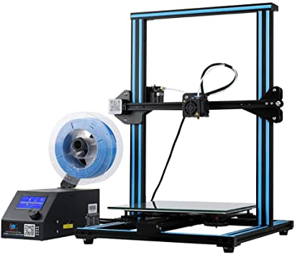
To be able to properly get help, it is important that you know the right terminology of the parts. It will significantly increase your results and reduce your time seeking help. Searching for “Hotend drive carriage loose” will immediately show you the solution while “wobbly heater for 3D printer”, will maybe leave you hanging for a few hours.
In this book I am using a creality CR10 as a base model, but this works for most RepRap type of printers. By the way, did you know that RepRap comes from “replication rapid prototyper”?

The concept of these printers is always the same. The filament is pushed to a hot nozzle. This nozzle melts the filament and releases the filament. As this nozzle is moving during the melting, while it leaves a strip of plastic behind. This is not random but in an order that is leaves a figure behind. Once a layer is done, it will move a tiny bit upward and start over making the same figure. The first layer “glues” to the second layer, the second to the third and so on, leaving behind a 3D object. 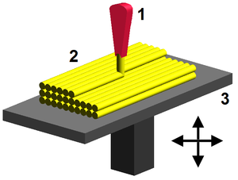
This process is also called Fused Deposition modelling or FDM

The Axis
In general there are 3 types of printers as you can see on the picture below. In this book we focus on a Cartesian type of printer.
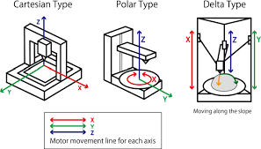
Understanding the axis of your printer, starts with understanding the movement of the printer.
The bed, that moves backwards and forwards, moves in the Y direction.
The hotend, where the plastics runs from, moves horizontally, in what is called the X direction.
And the height, a vertical movement, is actually the Z direction.
You will often find that people online refer to these directions a simply X,Y,Z direction

Construction
These printer are often constructed in using aluminum 2020 or 4020 profiles. There are other that, in the past, make their own printer even using a wooden frame, but I would advise against this, due to fire risks.
The Creality machines are usually made of the aluminum profile and typically have a rectangular base (with a bar in the middle to move the bed on) and a U shaped frame in the vertical direction.
Depending on what you ordered you might have to start from scratch but often parts are already pre-assembled for you. In any case: follow the instructions that came with your printer to assemble it. Make sure that all angles are correct, so that an 90° is actually 90°. It has occurred more than once that prints fail due to the fact that it was improperly assembled. A tilted frame is clearly noticeable when printing larger pieces.

The bed
This is the part where you object is printed on. You can have a heated or non-heated bed.
As the word mention it already, a heated bed has the ability to heat up. This often helps to get a better adhesion to the bed. This is not the only item that makes a printed object stick. The temperature of the bed can vary, but for PLA you often use 50° while other materials like PETG require a higher temperature. More on this later.
A non-heated bed, obviously, does not have this ability. This will prevent you from printing PETG, but can perfectly be used for materials like PLA.
A heated bed itself consists out of 3 parts
- A Y carriage plate which is the plate that is connected to the stepper to generate movement
- The heater element generates the heat to warm the bed
- The bed itself
Often people use another layer for better adhesion, like a mirror or glass place. The bed itself can have small deformations, resulting in it not being completely flat. A mirror on the other hand is perfectly flat, given you a great surface to print on.

Extruder & Hotend
Very often the extruder and hotend are mistaken. The extruder is the mechanism that pushes the material forward. On a stick cr10, this is located at the left side of the printer and looks like this
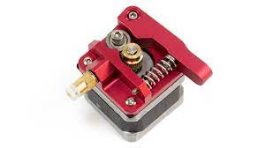
Your extruder can have a different color or look slightly different. Important to know is that you need to put the filament through it, or nothing will be fed to the hotend.
The hotend is the actual part that heats up the filament.
It looks like the picture below on the left. You might not see it, as this is usually behind a fan cover, shown on the right
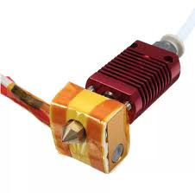
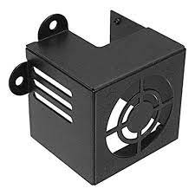

Anatomy of an extruder
There are multiple types of extruders available on the market. The stock extruder of the CR10 is a plastic one. Shown on the left. You can find full metal or aluminum extruders too, those will last longer and have a better flow of filament. An example is shown in the center. You can also find dual gear extruders. An example of this is below on the right.
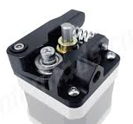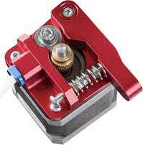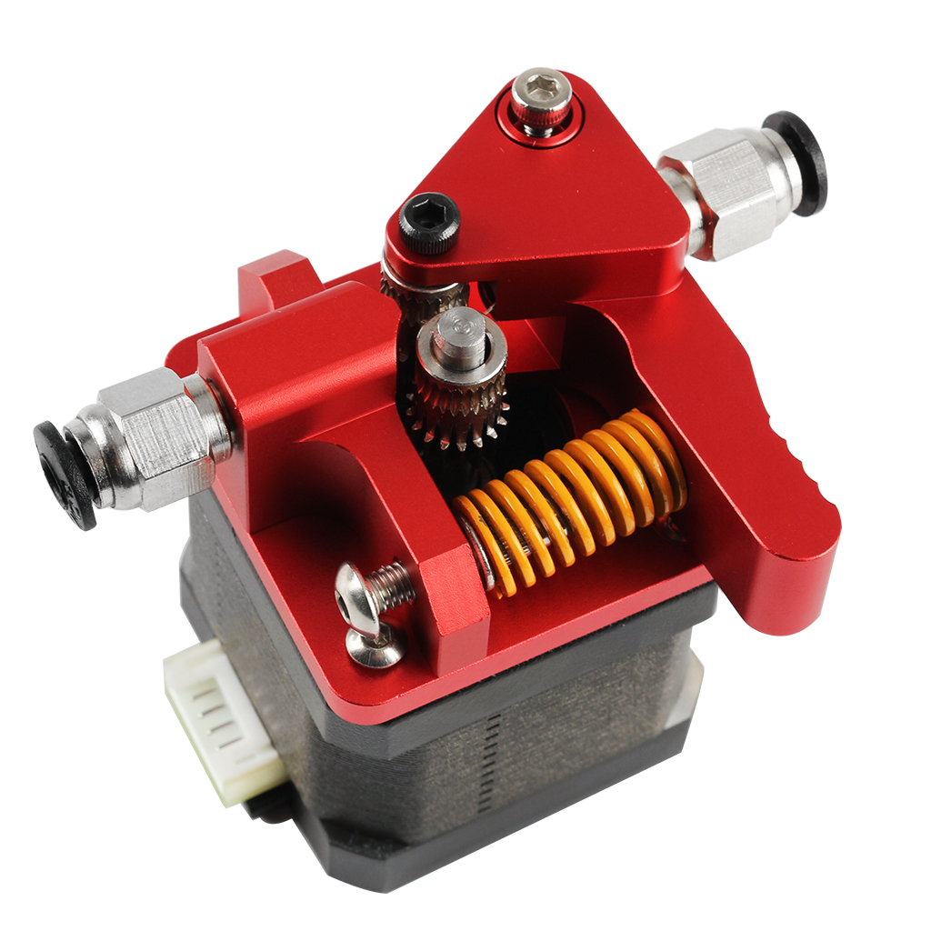

Anatomy of a hotend
The hotend itself consists out of multiple parts.
From top to bottom you will find a coupler. This coupler hold the bowden tube in place so it doesn’t pop out while printing.
This coupler is usually screwed into the heat sink, sometimes also called the radiator.
Inside the heatsink you will find the heat break. The heatbreak on it’s turn, goes into the heat block. This is the actually part that gets hot. Inside the heat block you will find a heater cartridge, a tiny element that heats the block.
The heat break then connects to the nozzle.
The heatblock, heater cartridge, nozzle and hot part of the heat break is called the Hot zone. Everything above, as of the heat sink, is the Cool zone.
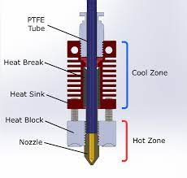
This actually explains where there is a fan in from of the radiator.
The intention is that the filament is only molten as of a certain spot, so it does not create any clogs and gives you a proper transport to the nozzle. Imagine that the filament is molten very high upwards; it would be impossible for the extruder to push it through the nozzle properly!
One item not described is indicated as PTFE tube, often called bowden tube. PFTE is commonly known under the product name Teflon.
This tube connects the exit of the extruder with the entrance of the hot end, creating a pathway for the filament.A PFTE tube is used as this has low friction and small tolerances, making it ideal for 3D printing as it won’t impact or stop the filament from fluent moving to the hot end.

Stepper motors
You will often find 4 or 5 stepper motors on a 3D printer.
One stepper is responsible for the movement of the bed in the Y direction. On the stepper a timing pulley is mounted that will drive a timing belt. The belt is connected to the bed and as the belt is moved, the bed is moved forward or backwards
Another stepper is used to drive the hotend. Well, to be completely correct, it is driving the X hotend carriage when the hotend is mounted on. It is a similar design to the movement of the bed. A pulley drives a belt, which on it turn moves the carriage.
At least 1 stepper is used to move the gantry in the vertical (or Z) direction. The stepper is connected to a rod via a coupler. By rotation the stepper the gantry is either going up or down. Did I mention that the gantry is the name for the horizontal bar, holding the drive carriage of the hotend?
Sometimes you will that printers have 2 steppers for the gantry.
The final stepper motor is used to drive the extruder.

Endstops
The endstops is a fancy word for small switches that get toggled as a part of the printer bumps against it. There are 3 endstops in the printer, the X-endstop, the Y-endstop and, you guessed it, the Z-endstop.
When e.g. the bed bumps the Y endstop, the printer knows it is at it’s starting point in relation to the bed. When the drive carriage of the hotend bumps against the X-endstop, this points that the drive is at it’s start point. The starting points are also considered the 0-point. If the machine moved the bed to the 0 position and the hotend also to the 0 position, it sits at 0,0.
The Z-axis end stop works similarly. The gantry moves down and when it bumps against the Z-endstop is is at 0 on the Z-axis.
If the machine move the bed, hotend and gantry to their respective 0 position, the machines nozzle sits at 0,0,0.
Several new machine already replace the Z-stop with a BL-Touch, ABL or any other mechanism to indicate that 0 position on the Z-axis. More on these later in this book.

The Controlbox
Depending on your printer, the control box might actually be a separate box, but on some machine (like the ender or CR10 Pro) the hardware is embedded to the frame.
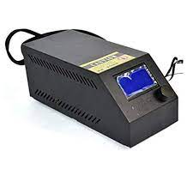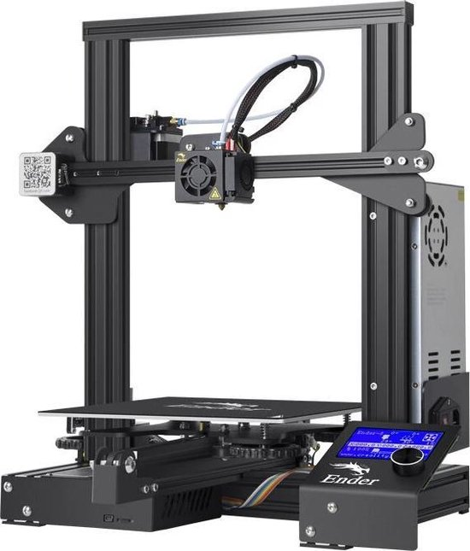
Independent of which machine you have they will also contain the following part
- Power supply
- Mainboard
- LCD display
- SD card reader / USB port
There are several projects to get rid of the external control box and mount the parts to the frame. This is done to save space on your desk.
After this chapter you know the most important parts of your printer. We will get more familiar with them as we dive deeper into the world of 3D printing.

Your first print

Loading the material
Obviously, without any filament loaded, you cannot print. Start by placing your filament through the extruder. You need to push on the lever to release the pressure and let the filament slide all the way up to the end to the hot end

Leveling the bed
Before you an actually start printing, the most crucial step is to level the bed.
Between the bed and the Y carriage there are springs and leveling screws. By rotating the screws you will either lower or raise the bed
Attention: level the bed has nothing to with using a level and making sure it is flat towards the earth. Leveling the bed means that we make sure that the gantry is parallel to the bed. This way the distance between the nozzle and the bed is equal on all spots of the bed.
First of all you have to home your printing. Homing is the activity to place the printer on it 0,0,0 position.
To do that, when using Marlin firmware, click on the button, select Move Axis and next choose Auto Home. This will home the printer for you.
We want to be able to move the bed and nozzle manually, but the steppers are enabled. This means that we cannot move them by hand. Do not try to move them or force them. You might damage you stepper, pulley, belts and so one.
To disable the steppers, simply go to the menu, select move axis and select “disable steppers”. You can now move the bed and hotend manually and without a lot of force.
The easiest way to level your bed is to move the nozzle approximately above the first leveling screws. Take a piece of paper and place it under the nozzle. If you cannot put it under the nozzle, your bed is too high. Turn the leveling screw to lower the bed until you can move it under it. Next move it back up until the piece of paper just touches the nozzle. You can still move it, but their is a slight resistance.
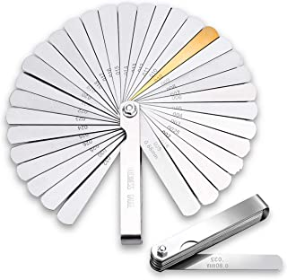
Do this action for all four leveling screws. When done, you are ready to print.
Tip: the paper trick is often described as the leveling method online. You could also buy some metal shims. I personally level my bed using a 0.15mm shims

Loading a file and printing
You can now print your first object. Typically the SD card that came with your printer will have a first object to print. Very often it is a cat or a dog.
To start this print, enter the menu, click on SD Card and select the file on there. The printer will now home again, heat the bed and hotend and start printing.
After a few hours you will have your first 3D printed object.
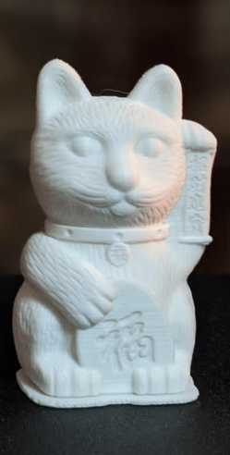

Finetuning your printer
Did you enjoy that first print? Good! But there is still a lot we can do to make your printer even better. Let’s go!

Extruder Esteps
Before we can start setting the extruder e-steps, it is important for you to understand what e-steps are. Easily said: this is the amount of steps or stepping turns the stepper motor does to push through 1mm of filament.
In a ideal state, when we print, if the object requires 1mm of filament, it will push 1mm. This is a value you can modify in the firmware. When this value is wrong, we can have that the extruder pushed more than 1 mm and we get too much (and this is called overextrusion) or less then 1 mm we don’t get enough (called underextrusion)
There are 2 ways to calibrate the e-steps: free air or through the extruder. I will run you through both of the methods.

Through the Extruder calibration
This is the most common way to check if you calibration is correct.
To perform this type of calibration we will first measure 120mm before the extruder, mark it and then tell the printer to feed 100mm.
- Heat the nozzle
As a first step we need to make sure that the nozzle is hot. The printer will refuse to extrude material with a cold nozzle. To heat it up, within the menu , go to control and select temperature. Now set the extruder temp to 180.
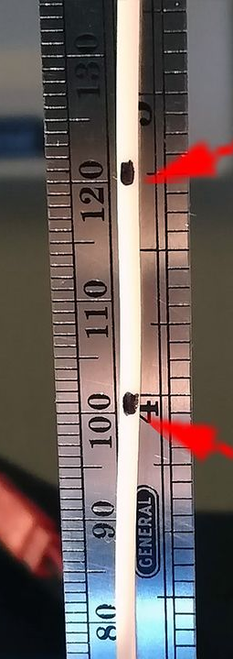
- Mark 120mm of material
Now mark 120mm and 100mm before the extruder. Use preferably a good marker which is clear on your filament. E.g. a black line on white works really well. Once you have marked it, we move to the next step.
- Extrude 100mm
Go to the menu, select prepare and go to move axis. Now set the E to 100mm. The printer is now asked to extruder 100mm of material
- Check the result
Remeasure how much the mark has moved towards the extruder. If you e-steps are set up correctly, your e-steps are set up correctly and no adjustments have to be made. Yet very often you will find that the distance is smaller than 20mm (and the printer has extruder too much filament) or that the distance is longer than 20mm and you have underextrusion.
- Calculate the new value
First find your current value. You can see it in the menu under control —> Motion —> Steps in MM. This is e.g. 80
Let’s assume that we still measured 25mm after the extrusion of the 100mm. In an ideal world this would have been exactly 20mm. In this case , we know that the extrusion only push out 95 mm (120-25) instead of the requested 100 and that means we have underextrusion.
So with a value of 80 we get 95 mm. We will need to increase this value to make sure that we get 100mm.
The formula for this is really simple
Current_esteps / Actual extruder length * 100
In our case this results to
80/95*100 = 84.21
We now know that we need to set the new e-steps value to 84.21. You can do this in the same location where we found it : control —> Motion —> Steps in MM and set the E value.
Remember to save you settings when done. (Control —> Store Settings)

Free air calibration
This type of calibration is very similar with the exception that we remove the bowden tube and measure after the extruder. This way there is no interference of a potential clog, or the friction of the bowden tube or anything that is past the stepper/extruder.
- Heat the nozzle
Similar to the previous way, you nozzle needs to be heated. Although you will not be extruding material through the nozzle, the printer does not know that and will not allow you to extrude with a cold nozzle
- Remove the bowden tube
Remove the bowden tube from the coupler right after the extruder. Cut your filament now right after the exit
- Request 100mm
Just as with the previous we version, we will request the printer to extruder 100mm.
- Measure how much was extruded
This is exactly the same as with the previous way. You simply measure how much material was actually extruded.
- Set the new value & set it
To calculate the new value, we use exactly the same formula
Current esteps / actual extruded length * 100.
We can now set it in the same way as you would do for a through extruder calibration.

Slicing a drawing to a GCODE you can print

What is GCODE?
GCODE is the language your printer speaks. GCODE is a human readabile format consistening out ouf lines smillar like
M28
G1 100 E100 F100

Although this might be very cryptic to you now, the language itself is very easily build up: You always have an instruction (G1, M28) and if the instruction requires parameters they come after it (in this was 100 E100 F110).
Each line represents an instruction. In the example M28 means to home the printer , while G1 is a coordinated movement. You can find a full list on the internet on sites like https://en.wikipedia.org/wiki/G-code#List_of_M-codes_commonly_found_on_FANUC_and_similarly_designed_controls_for_milling_and_turning
Luckily you do not need to write the GCode yourself. We can turn an STL file (a 3D object or stereolithography design) into GCode. This process is called slicing and done with a piece of software called a slicer. There are several well known slicers like Cura, PrusaSlicer or sSimplify3D.
In this book we will use Cura, a slicer developed by Ultimaker B.V.

X/Y/Z E-steps
Advanced Cura settings

Printing a temp tower

Printing an overhang tower

PID Tuning hotend and bed

Setting Extraction

Bed adhesion and warping

Preparing objects to print
Where to find object?
Generating Gcode a.k.a slicing
Cura tips and tricks

Using a raspberry pi with your printer

Why? Benefits

How-to install?

Usefull plugins

Compiling your own marlin firmware

Why?

Usefull functions
M85/ BL Touch/Meatpack/ARC/

Basic compilation tutorial

Modifications to your printer
Different Heat breaks
3D printable
New Mainboard?
Steppers
Stepper drivers
Direct Drive vs Bowden

Picture from Amazon
Picture from Wikipedia
Picture from amazon
Pictures from amazon
Picture: printermods.com
Picture: bol.com
Picture: reprap.me
Picture : https://www.crealityexperts.com/creality-hot-end-repair-guide
Control Box: Picture Amazon
Ender 3 has the component attached to the printers’ frame
Picture: amazon.com

